My cv
Brenda Pamela
68-4022,
Kadongo.
0758106190
brendapamela180@gmail.com

My personal details
Name: Brenda Pamela
Nickname: Precious Seth
My love :Seth Owino
Nickname:Seth Precious
Id number:854653457
Mother’s name: Dorothy Atieno
Father’s name : Jared Oloo

Professional summary
Bachelor of science in community development
Studying at Egerton University
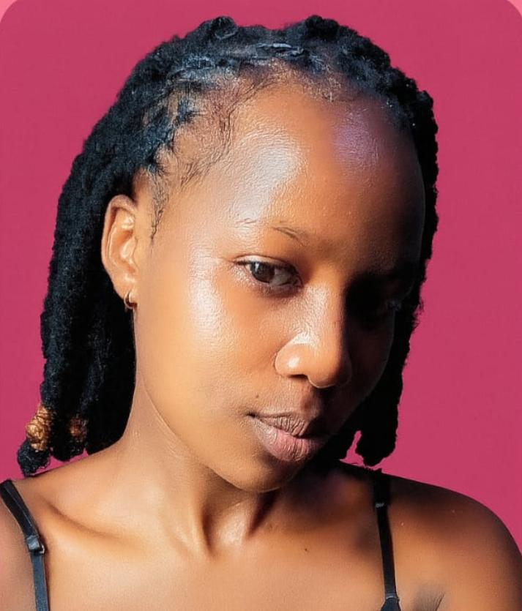
Lives in Nakuru

My Hobbies /skills
- Research and Innovation
- Studying
- Singing and dancing
- Playing games
- Spending time with my friends
My Goals
- Finnish school
- Find a genuine job
- Get married & live a peaceful and happy life together with my husband
@sethowinoprecious
Follow me at:
- Instagram @caliop Cruz
- Tiktok -@seth205
- Facebook @ caliop Cruz

